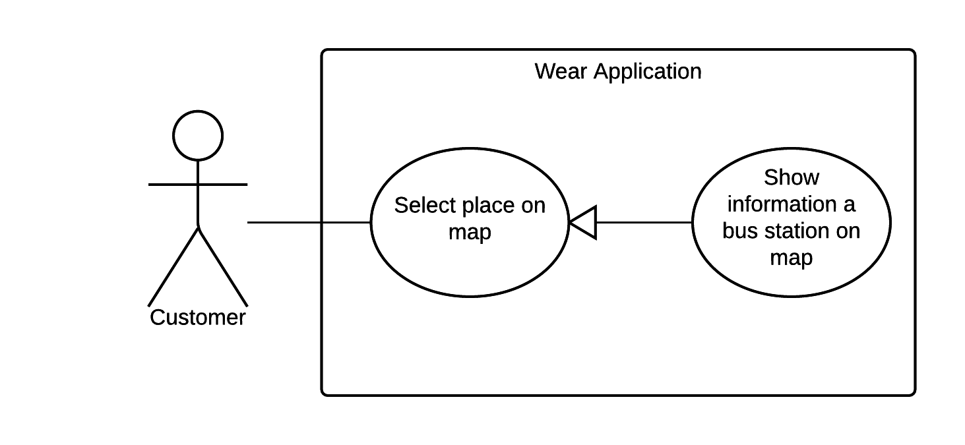

|  |  |  |  |
| --- | --- | --- | --- |
| USE CASE – WS10 | | | |
| Use Case No. | WS10 | **Use Case Version** | 1.0 |
| Use Case Name | Show information a bus station on map | | |
| Author | NamNT | | |
| Date | 27/05/2015 | **Priority** | Medium |
| Actor:   * Customer.   Summary:   * This use case allows customer select place to see notification of it.   Goal:   * Map move to a bus station which customer tap on and show notification of it.   Triggers:   * Customer tap on bus station of trip.   Preconditions:   * Wear is paired with mobile. * Wear is synced with mobile. * Mobile must enable GPS. * Mobile must be connected to internet.   Post Conditions:   * Success: Map move to new place and show information of it. * Fail: Show error message.   Main Success Scenario:   |  |  |  | | --- | --- | --- | | Step | Actor Action | System Response | | 1 | Tap on one bus station of trip on map. | Map move to bus station which customer tap on and show information of it.  [Exception 1, 2, 3, 4] |   Alternative Scenario: N/A  Exceptions:   |  |  |  | | --- | --- | --- | | No. | Actor Action | System Response | | 1 | Wear is not paired | Show message to notify that wear is not paired. | | 2 | Wear is not synced | Show message to notify that wear is not synced. | | 3 | Mobile is not enabled GSP | Show message to notify that mobile is not enabled GSP. | | 4 | Mobile is not connected to internet | Show message to notify that mobile is not connected to internet. |   Relationships: N/A  Business Rules:   * Bus station which customer choose will be on center of map. | | | |

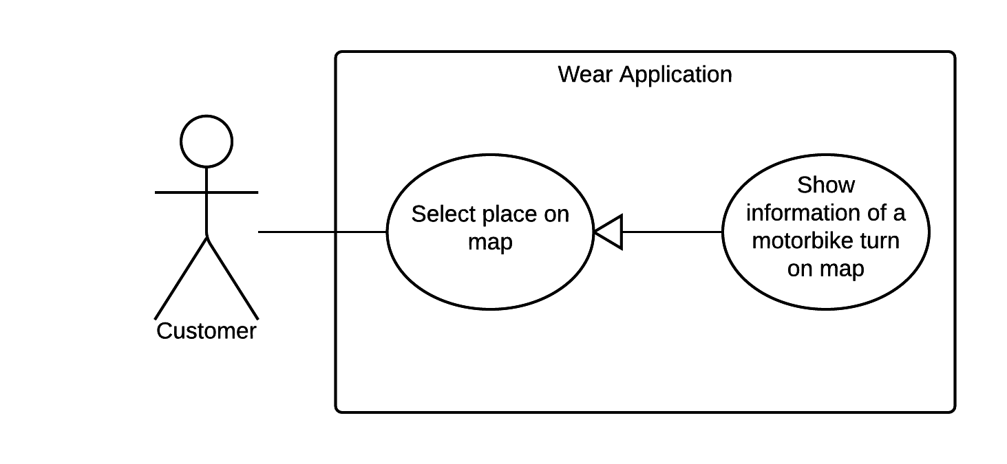

|  |  |  |  |
| --- | --- | --- | --- |
| USE CASE – WS10 | | | |
| Use Case No. | WS10 | **Use Case Version** | 1.0 |
| Use Case Name | Show information a motorbike turn on map | | |
| Author | NamNT | | |
| Date | 27/05/2015 | **Priority** | Medium |
| Actor:   * Customer.   Summary:   * This use case allows customer select place to see notification of it.   Goal:   * Map move to a motorbike turn which customer tap on and show notification of it.   Triggers:   * Customer tap on motorbike turn of trip.   Preconditions:   * Wear is paired with mobile. * Wear is synced with mobile. * Mobile must enable GPS. * Mobile must be connected to internet.   Post Conditions:   * Success: Map move to new place and show information of it. * Fail: Show error message.   Main Success Scenario:   |  |  |  | | --- | --- | --- | | Step | Actor Action | System Response | | 1 | Tap on one motorbike turn of trip. | Map move to motorbike turn which customer tap on and show information of it.  [Exception 1, 2, 3, 4] |   Alternative Scenario: N/A  Exceptions:   |  |  |  | | --- | --- | --- | | No. | Actor Action | System Response | | 1 | Wear is not paired | Show message to notify that wear is not paired. | | 2 | Wear is not synced | Show message to notify that wear is not synced. | | 3 | Mobile is not enabled GSP | Show message to notify that mobile is not enabled GSP. | | 4 | Mobile is not connected to internet | Show message to notify that mobile is not connected to internet. |   Relationships: N/A  Business Rules:   * Motorbike turn which customer choose will be on center of map. | | | |

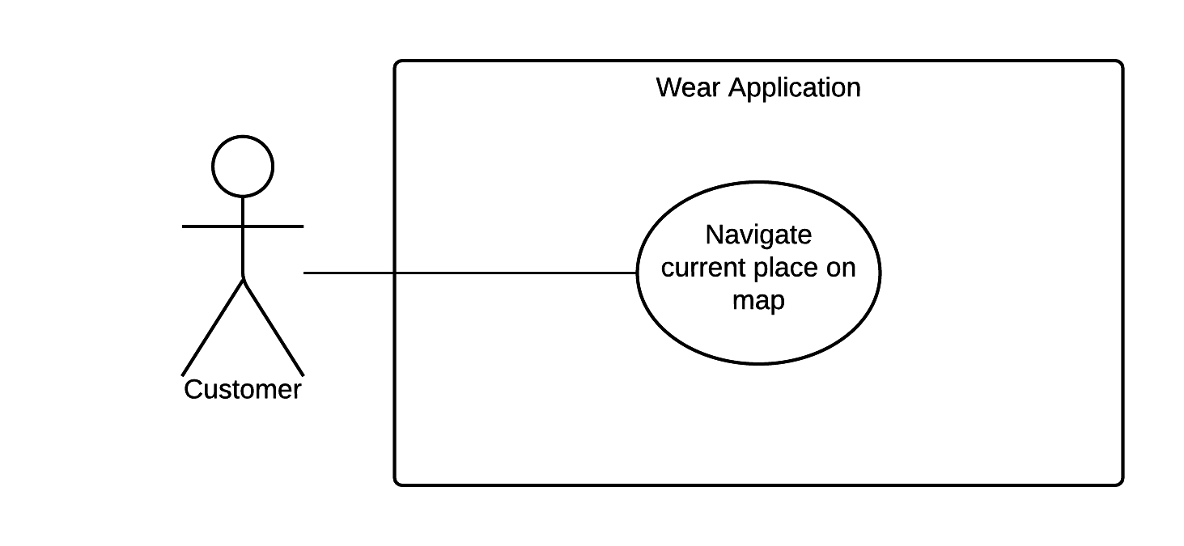

|  |  |  |  |
| --- | --- | --- | --- |
| USE CASE – WS10 | | | |
| Use Case No. | WS10 | **Use Case Version** | 1.0 |
| Use Case Name | Navigate current place on map | | |
| Author | NamNT | | |
| Date | 27/05/2015 | **Priority** | Medium |
| Actor:   * Customer.   Summary:   * This use case allows customer turn back to current place.   Goal:   * Map move to a current place.   Triggers:   * Customer tap on current place button.   Preconditions:   * Wear is paired with mobile. * Wear is synced with mobile. * Mobile must enable GPS. * Mobile must be connected to internet.   Post Conditions:   * Success: Map move to current place. * Fail: Show error message.   Main Success Scenario:   |  |  |  | | --- | --- | --- | | Step | Actor Action | System Response | | 1 | Tap on current place button. | Map move to current place.  [Exception 1, 2, 3, 4] |   Alternative Scenario: N/A  Exceptions:   |  |  |  | | --- | --- | --- | | No. | Actor Action | System Response | | 1 | Wear is not paired | Show message to notify that wear is not paired. | | 2 | Wear is not synced | Show message to notify that wear is not synced. | | 3 | Mobile is not enabled GSP | Show message to notify that mobile is not enabled GSP. | | 4 | Mobile is not connected to internet | Show message to notify that mobile is not connected to internet. |   Relationships: N/A  Business Rules:   * Current place will be show on center of map. | | | |

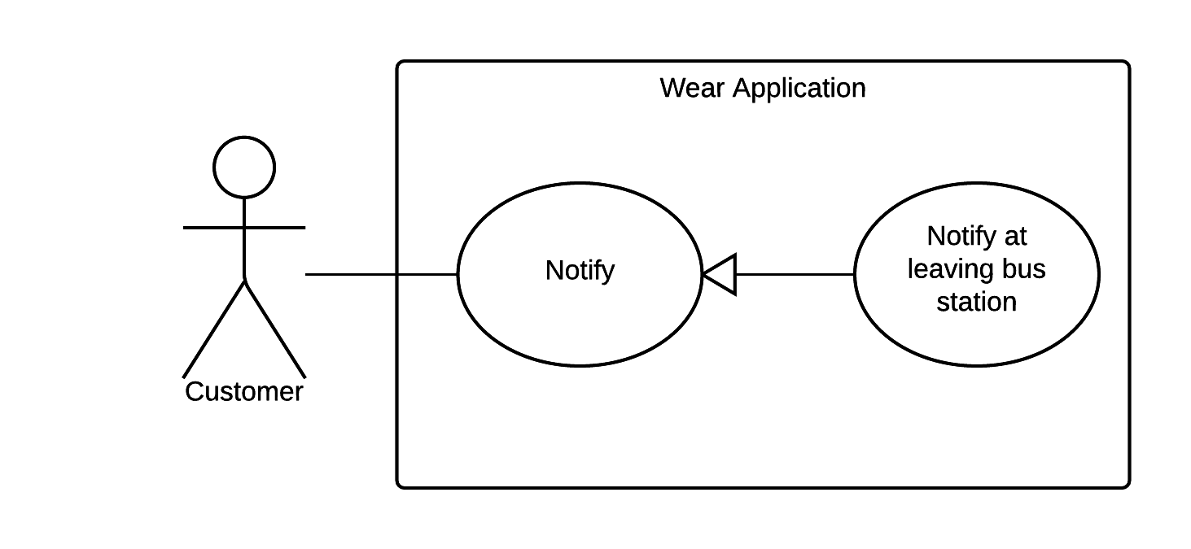

|  |  |  |  |
| --- | --- | --- | --- |
| USE CASE – WS10 | | | |
| Use Case No. | WS10 | **Use Case Version** | 1.0 |
| Use Case Name | Notify at leaving bus station | | |
| Author | NamNT | | |
| Date | 27/05/2015 | **Priority** | Medium |
| Actor:   * Customer.   Summary:   * This use case allows wear notify when customer is in circular range of station.   Goal:   * Wear will show notification when customer drivers nearly the leaving bus station of trip.   Triggers:   * Customer is near the leaving bus station.   Preconditions:   * Wear is paired with mobile. * Wear is synced with mobile. * Mobile must has GPS – enable. * Mobile must be connected to internet.   Post Conditions:   * Success: Wear show notification to customer. * Fail: Show error message.   Main Success Scenario:   |  |  |  | | --- | --- | --- | | Step | Actor Action | System Response | | 1 | Driver nearly the leaving bus station of trip. | Wear will show notification to customer.  [Exception 1, 2, 3, 4] |   Alternative Scenario: N/A  Exceptions:   |  |  |  | | --- | --- | --- | | No. | Actor Action | System Response | | 1 | Wear is not paired | Show message to notify that wear is not paired. | | 2 | Wear is not synced | Show message to notify that wear is not synced. | | 3 | Mobile is not enabled GSP | Show message to notify that mobile is not enabled GSP. | | 4 | Mobile is not connected to internet | Show message to notify that mobile is not connected to internet. |   Relationships: N/A  Business Rules:   * Notify to customer when bus is in circular range of leaving bus station and notify again after 1 minute later with special sound and vibrate. | | | |
|  | | | |

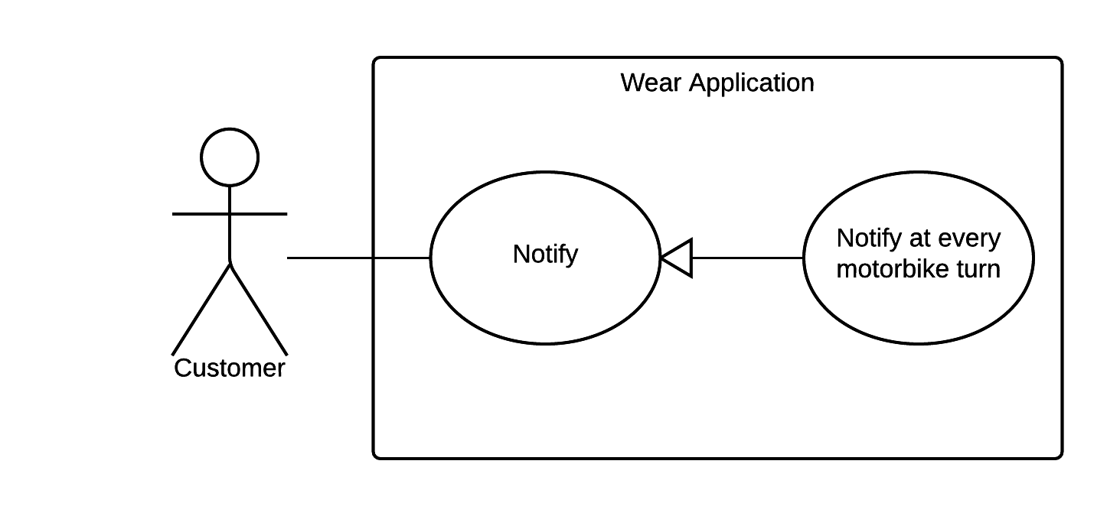

|  |  |  |  |
| --- | --- | --- | --- |
| USE CASE – WS10 | | | |
| Use Case No. | WS10 | **Use Case Version** | 1.0 |
| Use Case Name | Notify at motorbike turn | | |
| Author | NamNT | | |
| Date | 27/05/2015 | **Priority** | Medium |
| Actor:   * Customer.   Summary:   * This use case allows wear notify when customer is in circular range of turn.   Goal:   * Wear will show notification when customer drivers near the leaving bus station of trip.   Triggers:   * Customer is near the leaving bus station.   Preconditions:   * Wear is paired with mobile. * Wear is synced with mobile. * Mobile must has GPS – enable. * Mobile must be connected to internet.   Post Conditions:   * Success: Wear show notification to customer. * Fail: Show error message.   Main Success Scenario:   |  |  |  | | --- | --- | --- | | Step | Actor Action | System Response | | 1 | Driver near the motorbike turn of trip. | Wear will show notification to customer.  [Exception 1, 2, 3, 4] |   Alternative Scenario: N/A  Exceptions:   |  |  |  | | --- | --- | --- | | No. | Actor Action | System Response | | 1 | Wear is not paired | Show message to notify that wear is not paired. | | 2 | Wear is not synced | Show message to notify that wear is not synced. | | 3 | Mobile is not enabled GSP | Show message to notify that mobile is not enabled GSP. | | 4 | Mobile is not connected to internet | Show message to notify that mobile is not connected to internet. |   Relationships: N/A  Business Rules:   * Notify to customer when he/she is in circular range of motorbike turn and notify again after 1 minute later with special sound and vibrate. | | | |

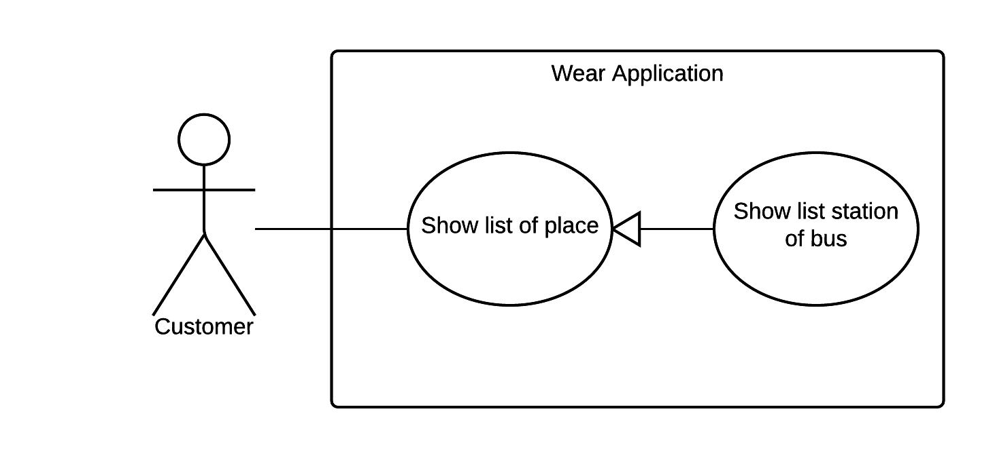

|  |  |  |  |
| --- | --- | --- | --- |
| USE CASE – WS10 | | | |
| Use Case No. | WS10 | **Use Case Version** | 1.0 |
| Use Case Name | Show list bus station | | |
| Author | NamNT | | |
| Date | 27/05/2015 | **Priority** | Medium |
| Actor:   * Customer.   Summary:   * This use case allows customer see all of leaving bus station.   Goal:   * Show all of leaving bus station on list.   Triggers:   * Tap on information of bus station.   Preconditions:   * Wear is paired with mobile. * Wear is synced with mobile. * Mobile must enable GPS. * Mobile must be connected to internet.   Post Conditions:   * Success: Wear show notification to customer. * Fail: Show error message.   Main Success Scenario:   |  |  |  | | --- | --- | --- | | Step | Actor Action | System Response | | 1 | Tap on information of bus station . | Show list of leaving bus station.  [Exception 1, 2, 3, 4] |   Alternative Scenario: N/A  Exceptions:   |  |  |  | | --- | --- | --- | | No. | Actor Action | System Response | | 1 | Wear is not paired | Show message to notify that wear is not paired. | | 2 | Wear is not synced | Show message to notify that wear is not synced. | | 3 | Mobile is not enabled GSP | Show message to notify that mobile is not enabled GSP. | | 4 | Mobile is not connected to internet | Show message to notify that mobile is not connected to internet. |   Relationships: N/A  Business Rules: Current leaving bus station will be on center of list. | | | |

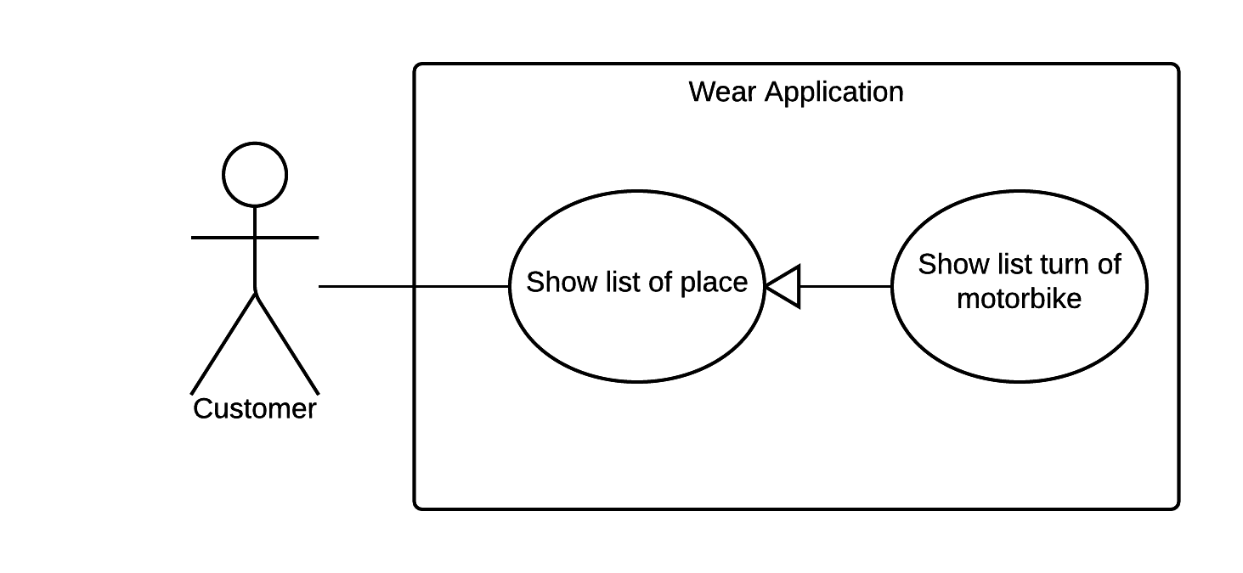

|  |  |  |  |
| --- | --- | --- | --- |
| USE CASE – WS10 | | | |
| Use Case No. | WS10 | **Use Case Version** | 1.0 |
| Use Case Name | Show list motorbike turn | | |
| Author | NamNT | | |
| Date | 27/05/2015 | **Priority** | Medium |
| Actor:   * Customer.   Summary:   * This use case allows customer see all of motorbike turn.   Goal:   * Show all of motorbike turn on list.   Triggers:   * Tap on information of bus station.   Preconditions:   * Wear is paired with mobile. * Wear is synced with mobile. * Mobile must enable GPS. * Mobile must be connected to internet.   Post Conditions:   * Success: Wear show notification to customer. * Fail: Show error message.   Main Success Scenario:   |  |  |  | | --- | --- | --- | | Step | Actor Action | System Response | | 1 | Tap on information of motorbike turn | Show list of motorbike turn .  [Exception 1, 2, 3, 4] |   Alternative Scenario: N/A  Exceptions:   |  |  |  | | --- | --- | --- | | No. | Actor Action | System Response | | 1 | Wear is not paired | Show message to notify that wear is not paired. | | 2 | Wear is not synced | Show message to notify that wear is not synced. | | 3 | Mobile is not enabled GSP | Show message to notify that mobile is not enabled GSP. | | 4 | Mobile is not connected to internet | Show message to notify that mobile is not connected to internet. |   Relationships: N/A  Business Rules: Current leaving bus station will be on center of list. | | | |

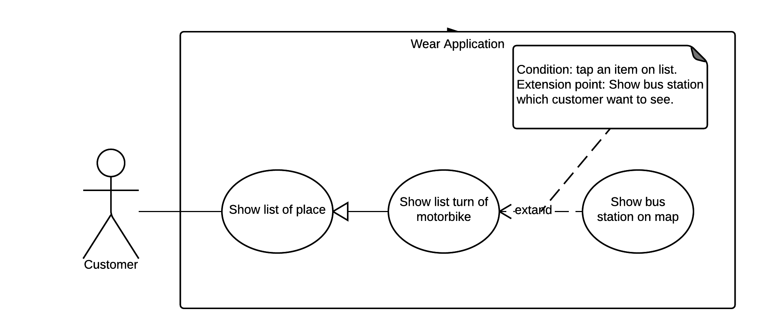

|  |  |  |  |
| --- | --- | --- | --- |
| USE CASE – WS10 | | | |
| Use Case No. | WS10 | **Use Case Version** | 1.0 |
| Use Case Name | Show bus station on map | | |
| Author | NamNT | | |
| Date | 27/05/2015 | **Priority** | Medium |
| Actor:   * Customer.   Summary:   * This use case allows customer see detail of leaving bus station on map.   Goal:   * Show leaving bus station and information of it on map.   Triggers:   * Tap on information of bus station.   Preconditions:   * Wear is paired with mobile. * Wear is synced with mobile. * Mobile must enable GPS. * Mobile must be connected to internet.   Post Conditions:   * Success: Wear show notification to customer. * Fail: Show error message.   Main Success Scenario:   |  |  |  | | --- | --- | --- | | Step | Actor Action | System Response | | 1 | Tap on information of bus station . | Show list of leaving bus station.  [Exception 1, 2, 3, 4] | | 2 | Tap on bus station of list | Show bus station and information of it on map.  [Exception 1, 2, 3, 4] |   Alternative Scenario: N/A  Exceptions:   |  |  |  | | --- | --- | --- | | No. | Actor Action | System Response | | 1 | Wear is not paired | Show message to notify that wear is not paired. | | 2 | Wear is not synced | Show message to notify that wear is not synced. | | 3 | Mobile is not enabled GSP | Show message to notify that mobile is not enabled GSP. | | 4 | Mobile is not connected to internet | Show message to notify that mobile is not connected to internet. |   Relationships: N/A  Business Rules: Bus station will be on center of map. | | | |

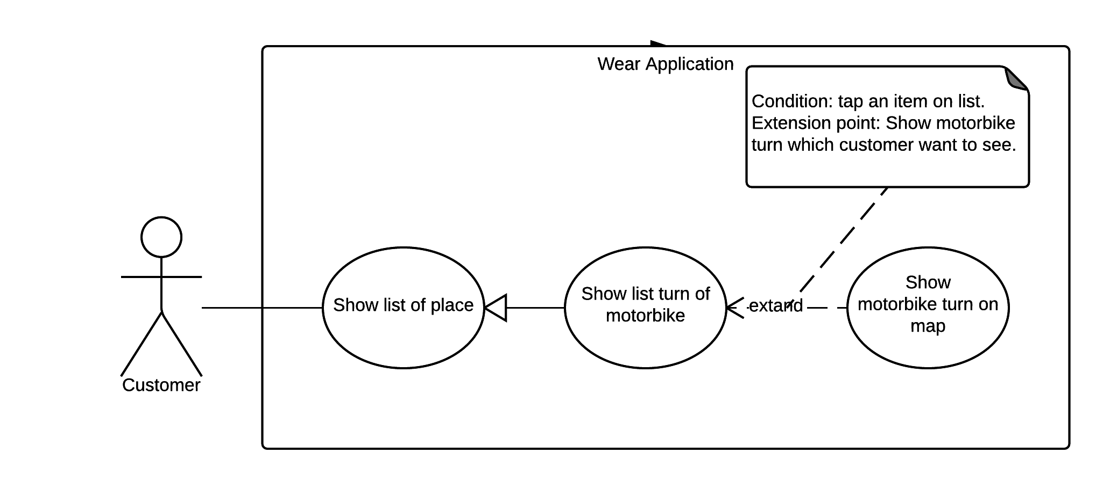

|  |  |  |  |
| --- | --- | --- | --- |
| USE CASE – WS10 | | | |
| Use Case No. | WS10 | **Use Case Version** | 1.0 |
| Use Case Name | Show motorbike turn on map | | |
| Author | NamNT | | |
| Date | 27/05/2015 | **Priority** | Medium |
| Actor:   * Customer.   Summary:   * This use case allows customer see detail of motorbike turn on map.   Goal:   * Show motorbike turn and information of it on map.   Triggers:   * Tap on information of motorbike turn.   Preconditions:   * Wear is paired with mobile. * Wear is synced with mobile. * Mobile must enable GPS. * Mobile must be connected to internet.   Post Conditions:   * Success: Wear show notification to customer. * Fail: Show error message.   Main Success Scenario:   |  |  |  | | --- | --- | --- | | Step | Actor Action | System Response | | 1 | Tap on information of motorbike turn . | Show list of motorbike turn.  [Exception 1, 2, 3, 4] | | 2 | Tap on motorbike turn of list | Show motorbike turn and information of it on map.  [Exception 1, 2, 3, 4] |   Alternative Scenario: N/A  Exceptions:   |  |  |  | | --- | --- | --- | | No. | Actor Action | System Response | | 1 | Wear is not paired | Show message to notify that wear is not paired. | | 2 | Wear is not synced | Show message to notify that wear is not synced. | | 3 | Mobile is not enabled GSP | Show message to notify that mobile is not enabled GSP. | | 4 | Mobile is not connected to internet | Show message to notify that mobile is not connected to internet. |   Relationships: N/A  Business Rules: Motorbike turn will be on center of map. | | | |